**Lab Manual- Azure VM with Azure PowerShell**

**Prepared for**: TechPledge

**Date:** 18th Nov 2018

**Prepared by:** Aditi Srivastava

Document Name: Lab Manual

**Document Number** DevOpsLab603

**Contributor:**

Shruti Sinhaa

Table of Contents

1 OBJECTIVE 3

2 PRE-REQUISISTE 3

3 Create a Windows virtual machine in Azure with PowerShell 3

3.1 **Launch Azure Cloud Shell** 3

3.2 **Create resource group** 3

3.3 **Create virtual machine** 3

3.4 **Connect to virtual machine** 4

3.5 **Install web server** 4

3.6 **View the web server in action** 5

3.7 **Clean up resources** 5

# OBJECTIVE

The Azure PowerShell module is used to create and manage Azure resources from the PowerShell command line or in scripts. This Lab shows you how to use the Azure PowerShell module to deploy a virtual machine (VM) in Azure that runs Windows Server 2016. You will also RDP to the VM and install the IIS web server, to show the VM in action.

# PRE-REQUISISTE

* Prior knowledge of Powershell
* Accounts in Azure

# Create a Windows virtual machine in Azure with PowerShell

## **Launch Azure Cloud Shell**

The Azure Cloud Shell is a free interactive shell that you can use to run the steps in this article. It has common Azure tools preinstalled and configured to use with your account.

To open the Cloud Shell, just select **Try it** from the upper right corner of a code block. You can also launch Cloud Shell in a separate browser tab by going to <https://shell.azure.com/powershell>. Select **Copy** to copy the blocks of code, paste it into the Cloud Shell, and press enter to run it.

## **Create resource group**

Create an Azure resource group with [New-AzResourceGroup](https://docs.microsoft.com/powershell/module/az.resources/new-azresourcegroup). A resource group is a logical container into which Azure resources are deployed and managed.

**New-AzResourceGroup -Name myResourceGroup -Location EastUS**

## **Create virtual machine**

Create a VM with [New-AzVM](https://docs.microsoft.com/powershell/module/az.compute/new-azvm). Provide names for each of the resources and the New-AzVM cmdlet creates if they don't already exist.

When prompted, provide a username and password to be used as the sign-in credentials for the VM:

**New-AzVm `**

**-ResourceGroupName "myResourceGroup" `**

**-Name "myVM" `**

**-Location "East US" `**

**-VirtualNetworkName "myVnet" `**

**-SubnetName "mySubnet" `**

**-SecurityGroupName "myNetworkSecurityGroup" `**

**-PublicIpAddressName "myPublicIpAddress" `**

**-OpenPorts 80,3389**

## **Connect to virtual machine**

After the deployment has completed, RDP to the VM. To see your VM in action, the IIS web server is then installed.

To see the public IP address of the VM, use the [Get-AzPublicIpAddress](https://docs.microsoft.com/powershell/module/az.network/get-azpublicipaddress) cmdlet:

**Get-AzPublicIpAddress -ResourceGroupName "myResourceGroup" | Select "IpAddress"**

Use the following command to create a remote desktop session from your local computer. Replace the IP address with the public IP address of your VM.

**mstsc /v:publicIpAddress**

In the **Windows Security** window, select **More choices**, and then select **Use a different account**. Type the username as **localhost**\username, enter password you created for the virtual machine, and then click **OK**.

You may receive a certificate warning during the sign-in process. Click **Yes** or **Continue** to create the connection

## **Install web server**

To see your VM in action, install the IIS web server. Open a PowerShell prompt on the VM and run the following command:

**Install-WindowsFeature -name Web-Server -IncludeManagementTools**

When done, close the RDP connection to the VM.

## **View the web server in action**

With IIS installed and port 80 now open on your VM from the Internet, use a web browser of your choice to view the default IIS welcome page. Use the public IP address of your VM obtained in a previous step. The following example shows the default IIS web site:

[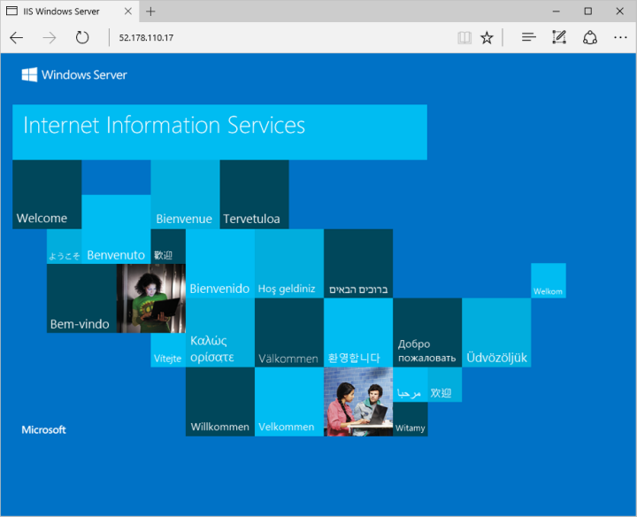](https://github.com/MicrosoftDocs/azure-docs/blob/master/articles/virtual-machines/windows/media/quick-create-powershell/default-iis-website.png)

## **Clean up resources**

When no longer needed, you can use the [Remove-AzResourceGroup](https://docs.microsoft.com/powershell/module/az.resources/remove-azresourcegroup) cmdlet to remove the resource group, VM, and all related resources:

**Remove-AzResourceGroup -Name myResourceGroup**